Overview
Youth STEM Journal Club Summer Program 2025
Program Outline and Parent-Student Information Packet
Program Overview
The Youth STEM Journal Club (YSJC) Summer Program provides students with the opportunity to explore their interest across STEM fields by engaging with real-world scientific literature under the guidance of experienced high school mentors.
Through a structured four-week session, students will read and discuss research papers in the fields of Computer Science, Neuroscience, Biology, Chemistry, Psychology, and Mathematics. Each topic group is led by a knowledgeable high school mentor with a strong background in their respective field.

Topic Groups
The following six STEM topics are offered:
- Computer Science
- Neuroscience
- Biology
- Chemistry
- Psychology
- Mathematics
Students may choose to join more than one group, subject to availability and time commitment. A mid-program opportunity to rotate between groups will be available.

Program Dates
Duration: Monday, June 30 – Saturday, July 26, 2025(4 weeks)
Final Presentations: Saturday, July 26, 2025

Participation Tracks
We offer three flexible tracks to accommodate student availability:
- In-Person Track
  - For students located in or near Fremont, CA (Classes will be hosted at the Fremont Main Library)
Strongly recommended to maximize collaborative learning
  - Attend two 1-hour in-person group meetings per week (see attached calendar for scheduling)
  - Participate in weekly online workshops
  - Final presentation delivered in-person
- Online Track
- For students who are not local or unavailable to commute
- Complete all readings and assignments asynchronously via Google Classroom
- Participate in weekly online workshops
- Final presentation delivered virtually
- Hybrid Track
- For students with intermittent availability or travel plans
- Attend at least 4 out of 8 in-person meetings
- Complete missed session content asynchronously
- Participate in weekly online workshops
- Presentation mode based on attendance (in-person or virtual)
Track selection will be finalized after the orientation session.

Academic Expectations
Although the time commitment is moderate, students are expected to complete asynchronous assignments, including pre-readings and background analysis. This is not a graded course, and no formal evaluations will be given. The emphasis of the program is on fostering scientific curiosity, mentorship, and open discussion, not assessments or tests.

Program Calendar
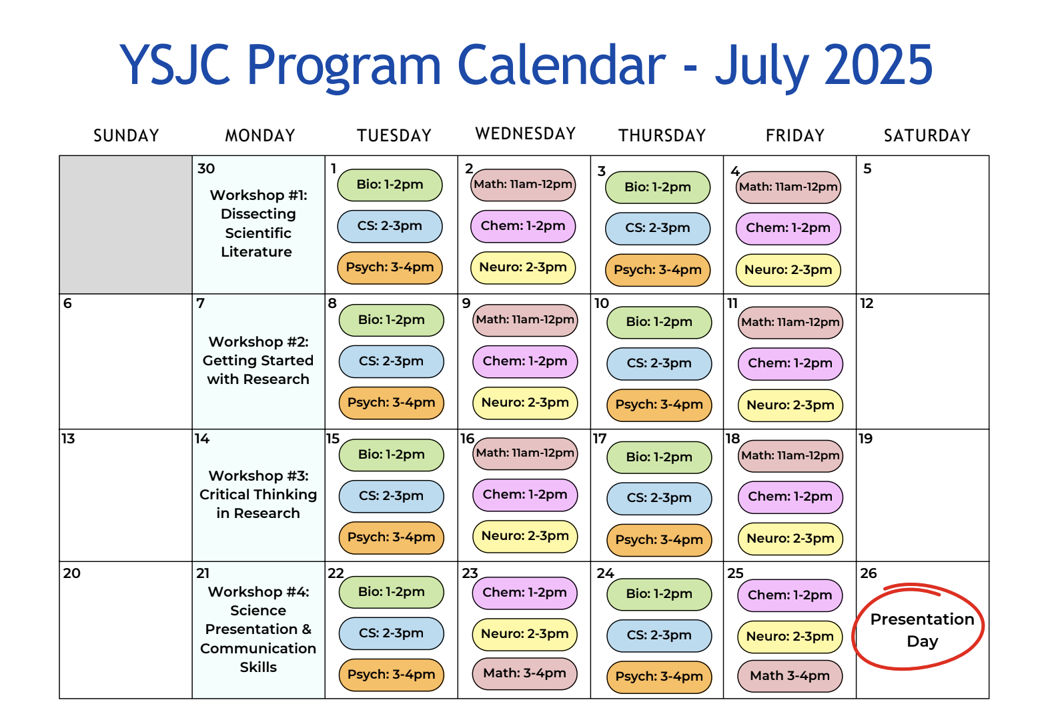
Each week will include:
- Group-specific meetings (in-person or online)
- All-program workshops every Monday
- Final Presentation Day on Saturday, July 26, 2025
Final Note
We are thrilled to begin this summer of exploration, discussion, and discovery. Thank you for joining us in making STEM research more approachable and meaningful to students. We look forward to meeting you soon!
For any questions, please contact us at:
ysjc.summerprogram@gmail.com

*subject syllabi, class rules, and the liability waiver are on the next few tabs

Subject Syllabi
YSJS Biology Syllabus 2025

YSJC Chemistry Syllabus 2025

YSJS Computer Science Syllabus 2025

YSJS Mathematics 2025

YSJS Neuroscience Syllabus 2025

YSJS Psychology Syllabus 2025

Class Rules
Youth STEM Journal Club (YSJC) – Summer 2025
Class Rules and Expectations
Location: Fremont Main Library & Online (Zoom)
As a participant in the Youth STEM Journal Club, you are expected to uphold a respectful, focused, and collaborative learning environment in both in-person and online settings. Please review the expectations below. All students must sign and return this form to confirm their understanding and agreement.

General Conduct
- Speak quietly and maintain appropriate volume at all times in the library.
- Avoid side conversations or unrelated activities during sessions.
- Show respect to mentors, peers, library staff, and visitors at all times.
Preparation and Participation
4. Complete the assigned reading (three pages per session) before group meetings.
5. Bring notes, questions, or reflections from the reading to contribute meaningfully.
6. Participate thoughtfully and respectfully in group discussions.
Library Etiquette
7. Keep the meeting space clean and organized. Throw away trash and reset chairs and tables as needed.
8. Food is not permitted inside library study rooms unless approved by staff. Water is allowed.
9. Use all library equipment and furniture with care.
Zoom Etiquette (Online Sessions)
10. Join Zoom sessions on time and with a stable internet connection.
11. Keep your microphone muted unless instructed otherwise.
12. Cameras must remain on during the session. Your full face (head to shoulders) should be clearly visible.
13. Use a neutral background and avoid multitasking during the session.
Punctuality and Attendance
14. Arrive on time to all meetings. Late arrivals disrupt the session and group focus.
15. If you must miss a session, inform your mentor in advance and complete any assigned work independently.
Consequences
Repeated failure to follow these expectations may result in a warning or dismissal from the program.

Acknowledgment and Agreement
I have read and understood the rules and expectations for participation in the Youth STEM Journal Club. I agree to follow them in all in-person and online sessions.
Student Name (Print): _______________________________________
Student Signature: ___________________________________________
Date: ___________________
Parent/Guardian Name (if under 18): ____________________________
Parent/Guardian Signature: ___________________________________
Date: ___________________

Liability Waiver
Youth Book Review Club Participation Waiver and Release of Liability
Hosted by: Youth STEM Journal Club
Location: Fremont Main Library 2400 Stevenson Blvd, Fremont, CA 94538
Dates: July-August 2025

Activity Description:

The Youth Book Review Club provides a safe, supportive space for middle school students to read and discuss research papers. The program is supervised by high school student volunteers (ages 15–17).

Liability Waiver - Please initial after each point on the line provided.
I, the undersigned parent or legal guardian of the participant named above, understand and agree to the following:
- I acknowledge that this activity involves reading, discussion, and snack consumption in a supervised but informal setting.
_______
- I understand that the student leaders supervising this program are minors (ages 15–17) and are not trained or certified caregivers.
_______
- I consent to my child’s participation in the Youth STEM Journal Club and release Youth STEM Journal Club, its organizers, volunteers, the hosting library, and its affiliates from any and all liability for injuries, accidents, or incidents that may occur during club activities.
______
- I confirm that my child does not have any known allergies to the snacks that will be provided or that I will inform the organizers in writing of any dietary restrictions or medical conditions prior to participation.
______
- I give permission for basic first aid to be administered to my child if needed and for emergency medical care to be sought if I cannot be reached in a timely manner.
_______

Photo Release - please check one of the following:

☐ I give permission for my child to be photographed during the program for promotional or documentation purposes.
☐ I do not give permission for my child to be photographed.

Participant Information:
Full Legal Name of Participant/Student: _____________________
Age: _____ Grade: ______
School Attending: _______________________
Allergies:______________________________ ☐Check this box if your child has no allergies.

Parent/Guardian Name: _______________________
Parent Phone Number: _________________Email: _________________

Emergency Contact Name: _____________________
Emergency Contact Phone Number: _________________

☐ I have read all information on this document, and I have checked or initialed all terms I agree to.

☐ All of the information I filled out is accurate.

Signatures:
Parent/Guardian Name (Printed): ___________________________
Signature: ____________________________________Date: ___________
Student/Participant Name (Printed): ___________________________
Signature: ____________________________________Date: ___________

